**DevOps Challenge V2**

**Question :** How would you further automate the management of the infrastructure if given unlimited time and resources?

I would have followed the following steps for automating the deployment of secure, publicly available HA Load-Balanced Web Servers that are available in different AWS availability zones and will automatically rebalance themselves if there is no healthy web server instance in either availability zone and redirecting any HTTP requests to HTTPS.

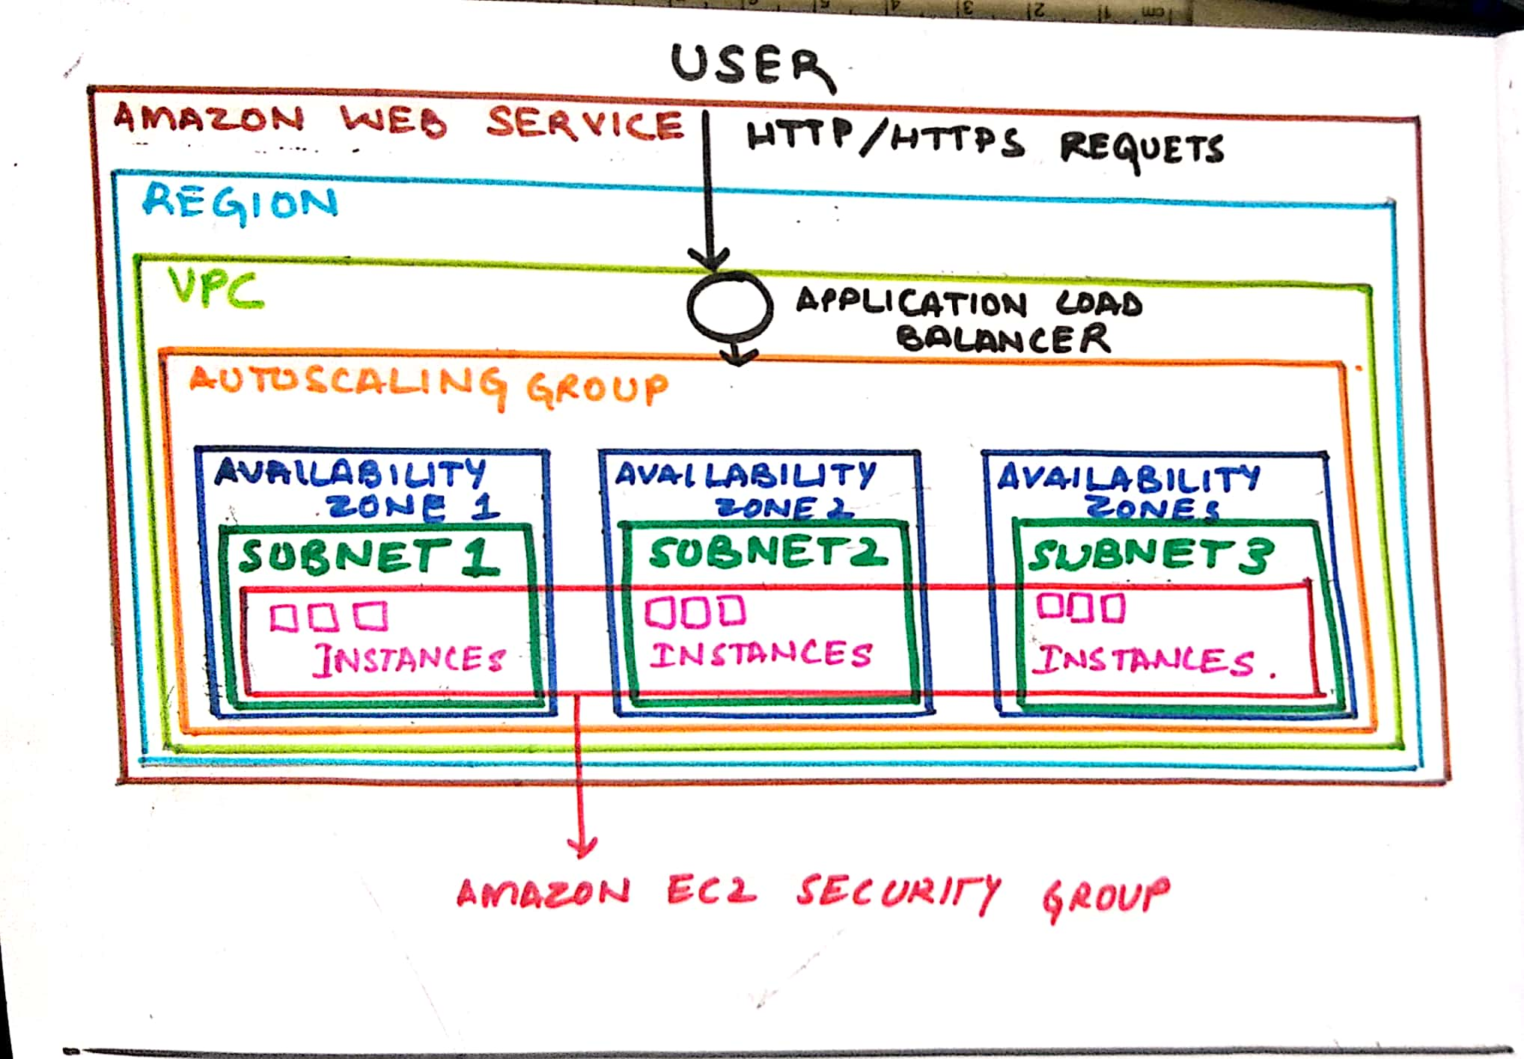

1. Launching Amazon EC2 Instances : We deploy Amazon EC2 instances. Specifying IP . Defining Security group since they exist in the same VPC for this case. We specify **different availability zones for the same region**.
2. Creating Elastic Load Balancer : We need properties of **health checkers** and **redirecting HTTP requests to HTTPS**.
   1. Health checker : This can be implemented by **choosing the option** given for it while deploying ELB.
   2. Redirect HTTP to HTTPS: Create listeners that acknowledge the HTTP requests.Under **Rules** section we select **Redirect to** action and mention HTTPS with its port. We need to **ensure the security group allows traffic on HTTPS port** .
3. Deploying Autoscaling : We create a template for autoscaling so as to distribute the traffic. In the **Network section** we **choose the VPC** we formed and **deployed** Amazon EC2 instances in **different availability zones for same region**. We then **attach the ELB** with all the specifications that we formed earlier.

I have done code on Terraform using AWS CLI and had deployed 3 Amazon EC2 instances on 3 subnets for different availability zones in the same region.

Zipped file contains :

1 word fil.

1 terraform code file named DevOpsV2.tf